vigna K R E S S F E L D

MERLOT RISERVA 2017

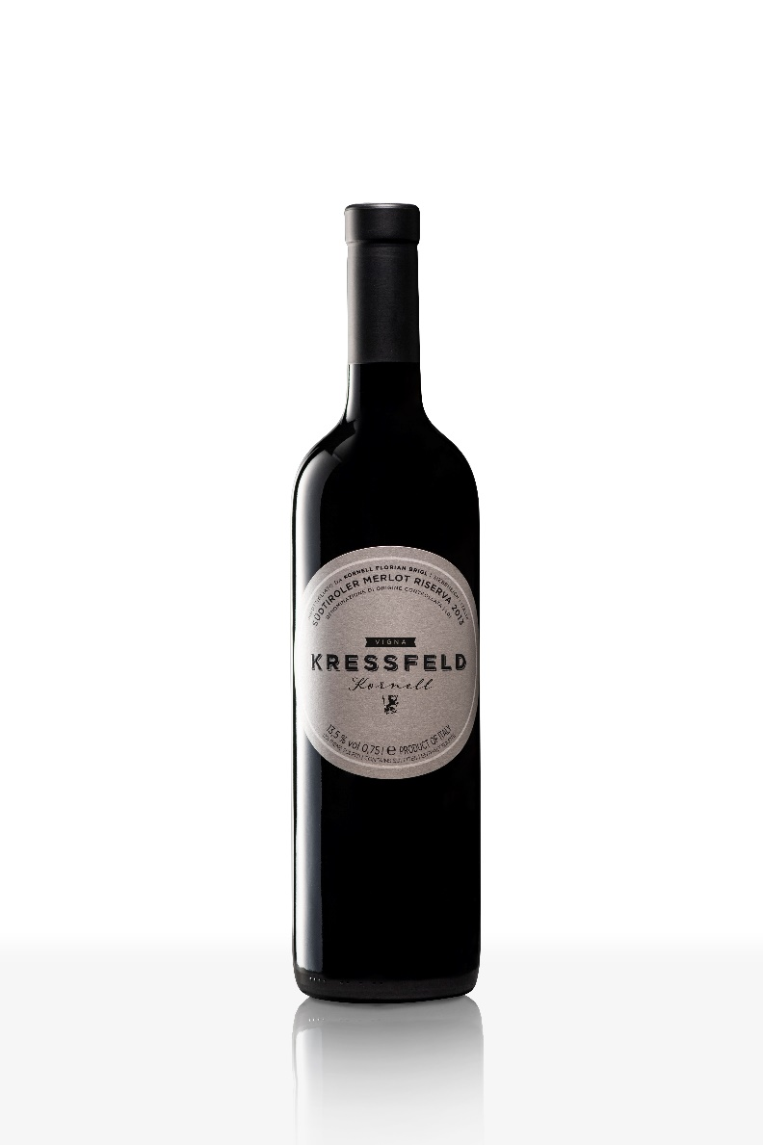

First vintage 2013

**TERROIR**

Site Kressfeld, Settequerce, Terlano

Altitude 280 m a.s.l.

Soil Porphyry weathered soil

Hillside South-west facing slope

Slope 10%

Pruning system Guyot

Vines/hectare 6000 pc/ ha

Yield/hectare 40 hl/ha

Harvest end of October

**Vintage 2017**

A year of challenges. Dry period and frost in April, as well as tropical nights and hot periods in summer, and again and again a lot of rain, hail in autumn, the yield is up to 15% less than in the previous year. Harvest began on August 25, 2 weeks earlier than the year before, the day and night differences in autumn were enough. In the end we were able to achieve a good vintage and are satisfied.

**VINIFICATION**

Vinification : Fermentation in small barrels for 25 days

Maturation: aging in new oak (barrique) for 18 months, aging in bottle for 24 months

Bottled: 4.000 bottles in March 2018

**ANALYTICAL DATA**

Alcohol 13,5 % vol

Residual sugar 0,5 g/l

Acidity 5,5 g

**Tasting Notes:**

Color: dark ruby red

Nose: multi-layered aromas of ripe plum and cherry

jam with spicy notes of chocolate, mint and tobacco,

elegant roasted aroma and a surprising freshness

Palate: elegance and structure in harmony, subtle,

soft tannins and a velvety fullness,

long and convincing finish

Aging potential: 20 years

Serving temperature: 16-18°C

Pairing suggestions: Angus beef fillet with pepper

sauce, bistecca alla Fiorentina, T-bone steak

WINERY KORNELL – FLORIAN BRIGL – VIA COSMA E DAMIANO 6

39018 SETTEQUERCE/TERLANO – ITALY – WWW.KORNELL.IT